**SOFTWARE REQUIREMENTS SPECIFICATION**

for

**NUTRICAREhub- A personalized food recommendation**

**system for disease management**

Prepared by:

|  |  |  |
| --- | --- | --- |
| **Specialization** | **SAP ID** | **Name** |
| AIML– B6 | 500108342 | Tanishka Kaul |
| AIML– B6 | 500106946 | Mahak Bansal |
| AIML– B6 | 500108278 | Prince Yadav |
| AIML– B5 | 500108005 | Rajvardhan Singh |

**Under the guidance of Dr. Virender Kadyan** Associate Professor



School Of Computer Science, University of Petroleum & Energy Studies, Dehradun- 248007. Uttarakhand

**Table of Contents**

|  |  |  |
| --- | --- | --- |
| **Topic** | | **Page No** |
| Table of Content | | 2 |
| Revision History | | 3 |
| 1 | Introduction | 3-4 |
|  | 1.1 Purpose of the Project | 3 |
|  | 1.2 Target Beneficiary | 3 |
|  | 1.3 Project Scope | 3 |
|  | 1.4 References | 4 |
| 2 | Project Description | 4-11 |
|  | 2.1 Reference Algorithm | 4-9 |
|  | 2.2 Data/ Data structure | 4 |
|  | 2.3 SWOT Analysis | 4 |
|  | 2.4 Project Features | 4-5 |
|  | 2.5 User Classes and Characteristics | 5 |
|  | 2.6 Design and Implementation Constraints | 5-6 |
|  | 2.7 Design diagrams | 6-8 |
|  | 2.8 Assumption and Dependencies | 9 |
| 3 | System Requirements | 9-11 |
|  | 3.1 User Interface | 9 |
|  | 3.2 Software Interface | 9 |
|  | 3.3 Database Interface | 10 |
| 4 | Non-functional Requirements | 10-11 |
|  | 4.1 Performance requirements | 10 |
|  | 4.2 Security requirements | 10-11 |
|  | 4.3 Software Quality Attributes | 11 |
| Appendix A: Glossary | | 11 |
| Appendix B: Issues List | | 11-12 |

**REVISION HISTORY**

|  |  |  |  |
| --- | --- | --- | --- |
| **DATE** | **CHANGES** | **REASON FOR CHANGES** | **MENTOR SGNATURE** |
| 19th September’24 | Project Name (Nutri care to NUTRICAREhub) | Common name |  |
| 19th September’24 | Go through weaknesses (SWOT Analysis) | To write more accurate weaknesses |  |
| 19th September’24 | Remove Docker | Restrictions for using docker |  |

1. **INTRODUCTION**
   1. **Purpose of the Project**

The purpose of NUTRICAREhub is to offer a personalized food recommendation system that assists individuals in managing chronic diseases through tailored nutrition. By analyzing user-specific health information such as disease type, dietary restrictions, and preferences, NUTRICAREhub delivers food choices optimized for conditions like diabetes, hypertension, and more. This system empowers users to make informed dietary decisions that support their health goals, improve quality of life, and reduce symptoms associated with chronic illness. NUTRICAREhub leverages data-driven recommendations and provides accessible, actionable guidance, ultimately bridging the gap between nutritional knowledge and disease management for long-term wellness.

* 1. **Target Beneficiary**

The target beneficiaries of NUTRICAREhub are individuals managing chronic health conditions, such as diabetes, hypertension, and cardiovascular diseases, who require customized dietary guidance for optimal health. This includes patients seeking tailored food recommendations that align with their medical needs, caregivers supporting dietary planning for loved ones, and healthcare professionals such as dietitians and doctors looking for reliable tools to assist patients in managing their conditions through nutrition. Additionally, health-conscious individuals aiming to prevent chronic conditions and maintain a balanced diet also benefit from Nutri care hub’s personalized recommendations and educational support.

* 1. **Project Scope**

The scope of NUTRICAREhub encompasses creating a web-based platform that provides personalized food recommendations to support chronic disease management. The system will cater to various health conditions such as diabetes, hypertension, and heart disease by offering tailored diet plans based on user-specific health profiles, dietary restrictions, and preferences. Core features include a user-friendly interface for profile creation, a recommendation engine that filters foods based on nutritional and medical guidelines, recipe suggestions, and nutritional analysis. The project will focus on developing accurate, data-driven recommendations, integrating nutritional databases, ensuring data security, and meeting regulatory requirements. Future enhancements may include mobile compatibility, AI-driven personalization, and health data tracking for improved user insights.

* 1. **References**

[1] Sowah, Robert A., Adelaide A. Bampoe-Addo, Stephen K. Armoo, Firibu K. Saalia, Francis Gatsi, and Baffour Sarkodie-Mensah. 2020. "Design and Development of Diabetes Management System Using Machine Learning." International Journal of Telemedicine and Applications 2020: Article ID 4909. <https://doi.org/10.1155/2020/8870141>.

[2] Goldstein, S. P., Zhang, F., Thomas, J. G., Butryn, M. L., Herbert, J. D., & Forman, E. M. (2018). Application of machine learning to predict dietary lapses during weight loss. Journal of Diabetes Science and Technology, 12(5), 1045–1052. https://doi.org/10.1177/1932296818775757

[3] Swaminathan, S., et al. "Development of a Field-Friendly Automated Dietary Assessment Tool and Nutrient Database for India." Nutrition Journal, vol. 14, no. 15, 2015, pp. 1-8. https://doi.org/10.1186/s12937-015-0039-6.

[4] Livingstone, M. B. E., and A. E. Black. "Biomarkers of Nutritional Exposure and Nutritional Status: Markers of the Validity of Reported Energy Intake." The Journal of Nutrition, vol. 133, no. 3, 2003, pp. 895S-920S. https://doi.org/10.1093/jn/133.3.895S.

[5] Masters, W. A., et al. "Exploring the Relationship Between Food Environment Indicators and Dietary Intake of Children 6–23 Months Old: Findings from 20 Low and Lower-Middle Income Countries." Global Food Security, vol. 28, 2021, 100518. <https://doi.org/10.1016/j.gfs.2021.100518>.

1. **PROJECT DESCRIPTION**
   1. **References Algorithm**

NUTRICAREhub recommendation algorithm combines **Content-Based Filtering** and **Rule-Based Filtering**. Content-Based Filtering evaluates food items based on their nutritional profiles, matching them to user needs and preferences. Rule-Based Filtering applies disease-specific constraints (e.g., low sodium for hypertension), ensuring recommendations are medically appropriate. The combination of these methods allows NUTRICAREhub to provide relevant, personalized food recommendations that align with dietary restrictions.

* 1. **Data/ Data Structure**

The NUTRICAREhub system utilizes structured datasets containing food items, nutritional values, and user health profiles. The food database stores items with detailed macronutrient and micronutrient breakdowns, while user profiles include age, gender, disease type, dietary preferences, and restrictions. Data is organized into classes and structures using C++ vectors, maps, and linked lists to optimize access and recommendation processing. Additional structures manage user interactions and store their dietary logs.

* 1. **SWOT Analysis**

**Strengths**: Personalized dietary guidance, disease-specific recommendations, reliable data-backed algorithms, scalable architecture.

**Weaknesses**: Reliance on accurate data sources, user adoption challenges, initial limited scope.

**Opportunities**: Partnerships with healthcare providers, AI integration, mobile expansion, potential for global adaptation.

**Threats**: Competition, regulatory requirements, privacy concerns, and data security risks.

* 1. **Project Features**

NUTRICAREhub is a personalized food recommendation system designed to aid in chronic disease management, providing dietary guidance tailored to conditions like diabetes and hypertension. It filters food options based on user health profiles and dietary restrictions, ensuring recommendations align with specific needs. Users receive nutritional analysis, recipe suggestions, and health tips, helping them make informed choices and track nutrient intake effectively.

NUTRICAREhub user-friendly interface and secure data management protect user information, making it accessible and reliable. With its tailored recommendations and educational resources, NUTRICAREhub empowers users to manage their health proactively through diet.

**Level-2 Use-case Diagrams**

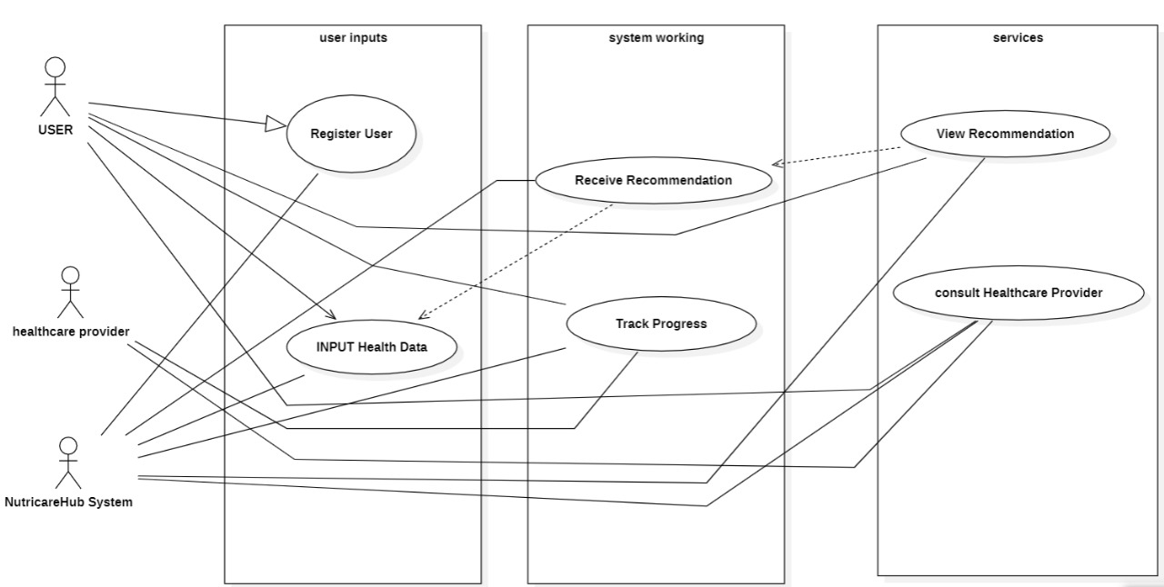

* 1. **User Classes and Characteristics**

1. **Patients with Chronic Diseases**

Characteristics: Individuals managing health conditions like diabetes, hypertension, or cardiovascular diseases who seek dietary guidance tailored to their medical needs. They prioritize food recommendations that help manage symptoms, maintain nutrient balance, and support overall health.

1. **Healthcare Professionals**

Characteristics: Doctors, dietitians, and nutritionists who use NUTRICAREhub as a tool to support patients in managing their conditions through diet. They focus on accurate, medically-relevant recommendations to supplement treatment plans and improve patient outcomes.

1. **Caregivers**

Characteristics: Family members or personal caregivers responsible for managing the diets of loved ones with chronic conditions. They use NUTRICAREhub to ensure meals meet dietary restrictions and support the health goals of those in their care.

1. **Health-Conscious Users**

Characteristics: Individuals interested in preventive health measures or improving dietary habits for general wellness. They use NUTRICAREhub to make nutritious food choices and access resources that support balanced diets and healthy lifestyles.

* 1. **Design and Implementation Constraints**

**Hardware Constraints:**

Memory and Processing Power: NUTRICAREhub must be optimized for limited memory and processing power on various devices, especially mobile.

Timing Requirements: Real-time or near-real-time data processing is essential for delivering quick recommendations to users.

**Interfaces to Other Applications:**

Healthcare Platforms: Potential integration with electronic health record (EHR) systems to gather and update patient data.

Nutritional Databases: Interfaces with reliable databases for current food and nutrient information.

**Specific Technologies and Tools:**

Front-End: HTML, CSS and JavaScript for user interface.

Back-End: C++ for algorithm implementation and data processing, with a database like MySQL for storage.

APIs: Nutrition and healthcare APIs to streamline data sourcing.

**Parallel Operations:**

Multi-threading: To ensure fast processing and user responsiveness, especially when handling simultaneous user requests.

**Language Requirements:**

Primary Language: C++ for high-efficiency data processing.

Additional Languages: JavaScript/React for interactive front-end features.

**Communication Protocols:**

HTTP/HTTPS: For secure, reliable data exchange between client and server.

REST APIs: To access and integrate external nutritional and healthcare data.

**Security Considerations:**

Data Encryption: Required for protecting sensitive user health data.

Authentication: User login and authentication protocols for data privacy.

Compliance: Adherence to data privacy laws like HIPAA and GDPR.

**Design Conventions or Programming Standards:**

Coding Standards: Following best practices in C++ and JavaScript to ensure code readability, maintainability, and consistency.

Documentation: Clear documentation for each module to support future updates.

Error Handling: Robust handling of exceptions and errors to improve user experience and maintain system stability.

* 1. **Design Diagrams**
     1. **Class Diagram**

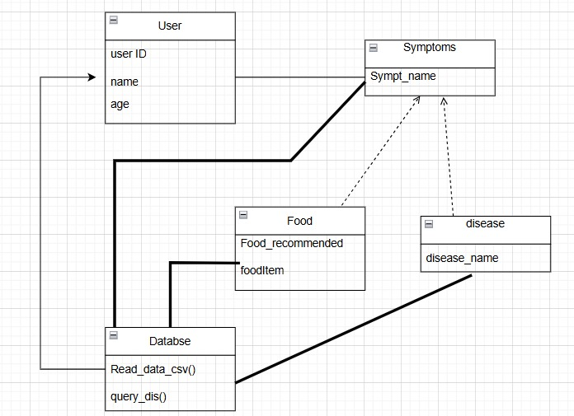

Fig. 2.7.1 Class Diagram

* + 1. **Sequence Diagram**

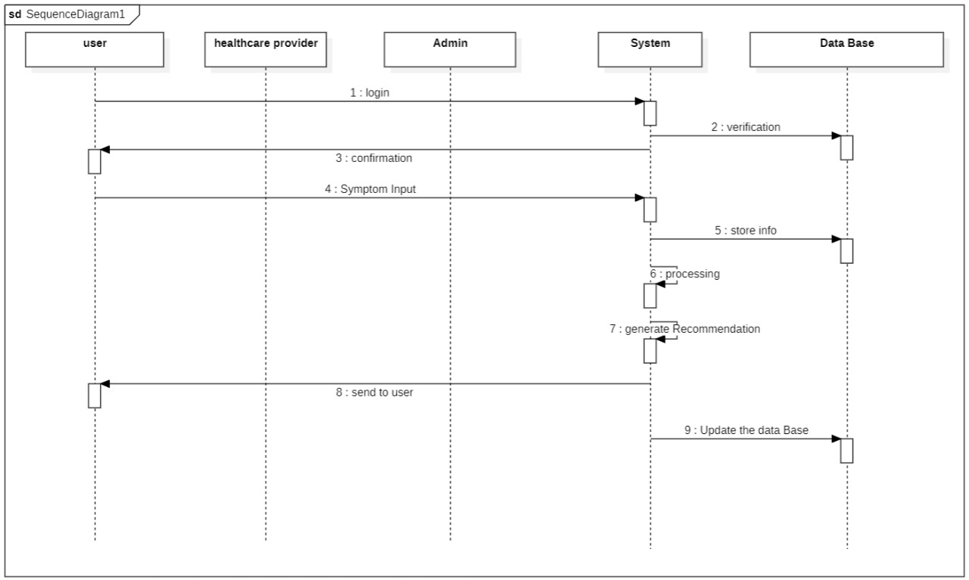

Fig. 2.7.2 Sequence Diagram

* + 1. **DFD Diagram**

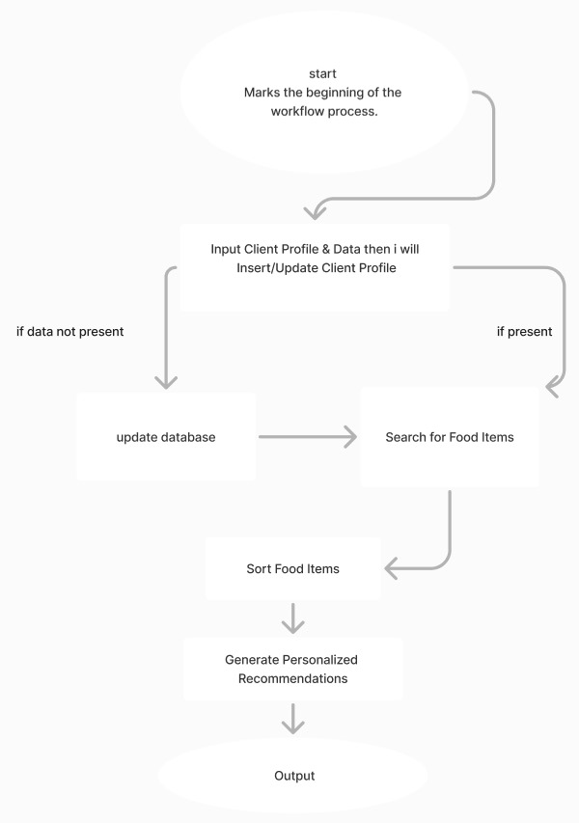

Fig.2.7.3 DFD diagram

* 1. **Assumptions and Dependencies**

**Assumptions:**

1. Users provide accurate health information.
2. Reliable access to updated nutritional databases.
3. User consistency in logging and following recommendations.
4. Device compatibility for smooth functionality.
5. Compliance with data privacy regulations.

**Dependencies:**

1. Access to external, up-to-date nutritional APIs.
2. Adherence to evolving data privacy and regulatory laws.
3. Reliable internet connectivity for data sync.
4. Secure integration with healthcare systems (EHRs).
5. **SYSTEM REQUIREMENTS**
   1. **User Interface**

**User Registration and Login:**

For users to create accounts, log in, and securely access personalized data.

**Profile Management:**

Allows users to update personal health information, dietary restrictions, and preferences.

**Food Recommendation Dashboard:**

Displays personalized food suggestions based on health conditions and dietary needs.

**Nutritional Analysis:**

Shows nutrient breakdown (macronutrients and micronutrients) for recommended foods and meals.

**Recipe Suggestions:**

Presents customized recipes incorporating recommended foods.

**Diet Tracking:**

Enables users to log meals, track dietary intake, and monitor progress over time.

**Health Tips and Alerts:**

Provides targeted health advice, reminders, and notifications based on user data.

**Educational Resources:**

Offers access to information on managing health conditions through diet.

**Settings and Preferences:**

Allows users to customize notification preferences, privacy settings, and other personal options.

* 1. **Software Interface**

NUTRICAREhub software interface connects essential modules for personalized health management. The User Interface (UI) Module retrieves and displays data from backend services, offering user-friendly access to food recommendations and nutrition analysis. The Recommendation Engine processes user health data by interacting with the User Profile and Nutritional Database, providing tailored food suggestions. The User Profile Management module handles user health details, while the Nutritional Database connects to external APIs for accurate food data. The Diet Tracking Module logs user intake, syncing with the User Profile to monitor dietary habits.

NUTRICAREhub employs RESTful API Services for secure HTTP communications, enabling synchronous real-time data requests for the UI and asynchronous notifications for alerts. Key APIs include endpoints for user data, recommendations, nutrition information, diet tracking, and notifications. This design ensures efficient, secure data flow, real-time processing, and personalized user interaction across the system.

* 1. **Database Interface**

The NutriCareHub database interface is designed to manage data flow between application modules and the backend databases for fast, accurate, and secure health recommendations.

Key components include:

**Disease-Symptom Database:**

Purpose: Quickly retrieves symptom-disease relationships to assist users in identifying potential health concerns.

Implementation: Optimized MySQL queries for fast access to disease and symptom data, ensuring minimal lag in user interactions.

**Food-Nutrition Database:**

Purpose: Provides detailed nutritional profiles, linking specific foods to potential health benefits for disease management.

Implementation: Pulls data from USDA and scientific sources, offering up-to-date nutrition insights, with the database structured for efficient nutrient and food access.

**User Profile Management:**

Purpose: Stores individual health data, including dietary restrictions and health history, to personalize food recommendations.

Implementation: Uses encrypted fields for sensitive information, maintaining privacy and security while enabling fast retrieval.

**External Reference Databases:**

Purpose: Ensures access to accurate and current disease and food information from sources like PubMed and WebMD.

Implementation: RESTful API calls maintain real-time updates and synchronization with external databases.

**Caching and Indexing:**

Purpose: Enhances response time for frequent queries, reducing server load.

Implementation: Indexed tables for commonly accessed data and caching mechanisms for repeated requests.

1. **NON-FUNCTIONAL REQUIREMENTS**
   1. **Performance Requirements**

Response Time: The NUTRICAREhub system should provide personalized food recommendations within 2-3 seconds under normal conditions.

Data Processing: Algorithms for generating food recommendations must handle user input and profile data in real-time or near real-time, ensuring an efficient user experience.

Scalability: The system should support concurrent use by at least 500 active users without performance degradation.

Database Queries: Must retrieve and update data within 1 second for user interactions, maintaining efficient data management even with large datasets.

* 1. **Security Requirements**

Data Encryption: User health data must be encrypted during storage and transmission to prevent unauthorized access.

Authentication: NUTRICAREhub requires secure user login, including password protection and multi-factor authentication for sensitive data.

Compliance: The system must adhere to HIPAA and GDPR regulations, ensuring the privacy and security of user health information.

Validation: Regular checks to ensure data accuracy and system integrity, including role-based access controls for sensitive modules.

* 1. **Software Quality Attributes**

Adaptability: NUTRICAREhub’s modular data structures (e.g., hash maps, trees) should allow easy integration of new dietary guidelines or health information. Using structures like AVL trees or B-trees enables efficient insertion and deletion of new data points without significant redesign.

1. Availability: The system should leverage efficient search algorithms (e.g., binary search for sorted data) and hashing techniques to ensure maximum availability, providing rapid access to dietary recommendations with minimal downtime.

2. Correctness: The recommendation system should utilize graph traversal algorithms to ensure that relationships between symptoms and dietary data are accurately represented, offering correct food suggestions based on user inputs and validated nutritional sources.

3. Interoperability: NUTRICAREhub should use standardized data structures like JSON trees or graphs for representing and sharing data across healthcare applications, ensuring compatibility with EHRs and other health-focused platforms.

4. Maintainability: The system should employ modular, object-oriented practices, ensuring that each algorithm (e.g., sorting algorithms for ranking diets) and data structure is independently manageable and easy to update.

5. Portability: NUTRICAREhub’s core data structures (like stacks, queues, and trees) and algorithms (e.g., merge sort for data preparation) should be designed to work across different platforms, ensuring functionality on both web and mobile interfaces.

6. Reliability: The recommendation engine should be based on reliable algorithms (e.g., priority queues for handling high-priority dietary suggestions), ensuring stable service and consistent performance, even under high user load.

7. Reusability: Core components, like binary trees for efficient search and hash maps for fast data retrieval, should be developed to be easily reusable for similar applications in healthcare or nutrition.

8. Robustness: NUTRICAREhub should handle exceptions and errors gracefully using defensive programming techniques in data structures like linked lists or circular buffers, enabling the system to continue functioning even with incomplete or incorrect inputs.

9. Testability: Each algorithmic module (e.g., recursive search algorithms for complex user queries) and data structure should undergo unit testing, covering of code to ensure efficient and reliable data processing.

10. Usability: User interactions should be facilitated by an intuitive interface backed by efficient operations like stack-based navigation or hash map lookups for real-time dietary suggestions, making it accessible for users of all backgrounds.

**Appendix A: Glossary**

* 1. API: Application Programming Interface, a set of rules for building software and applications.
  2. GDPR: General Data Protection Regulation, a regulation for data protection in the European Union.
  3. HIPAA: Health Insurance Portability and Accountability Act, a U.S. regulation to protect sensitive patient data.
  4. Nutritional Analysis: Breakdown of food into its macronutrients and micronutrients.
  5. User Profile: User’s personal health and dietary information used to personalize recommendations.

**Appendix B: Analysis Model**

1. Data Flow Diagrams (DFD): Illustrate the data processing and information flow across modules, such as user profile management, recommendation engine, and nutritional database.
2. Use Case Diagrams: Define interactions between users (patients, healthcare providers) and the system for activities like logging in, managing profiles, and receiving recommendations.
3. Sequence Diagram: The sequence diagram in NUTRICAREhub visually outlines interactions from symptom input to personalized recommendation delivery, detailing each component's communication flow.

**Appendix C: Issues List**

1. Data Accuracy: Ongoing need to verify and update nutritional information for accuracy.
2. API Stability: Dependence on external nutritional databases that may change or go offline.
3. Regulatory Compliance: Adapting to changing data protection and health data regulations.